....

Inside FactoryIO machine:

1. Open file explorer and goto C:\vagrant\FactoryIO-Projects\scenes_and_programs.
2. Open any scene having extension .factoryio, for example: P0_SimpleBand.factoryio. You should see like below for first time  
   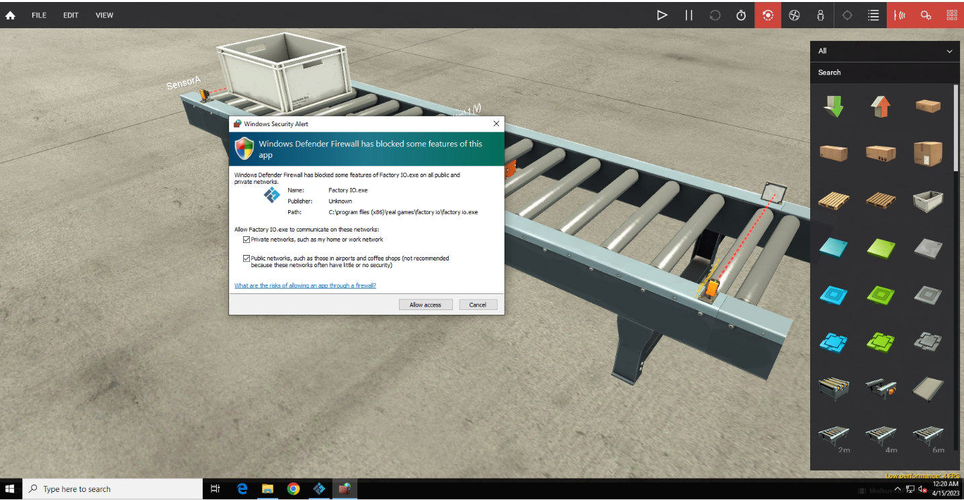
3. Make sure to Uncheck first checkbox and allow access and you should see this

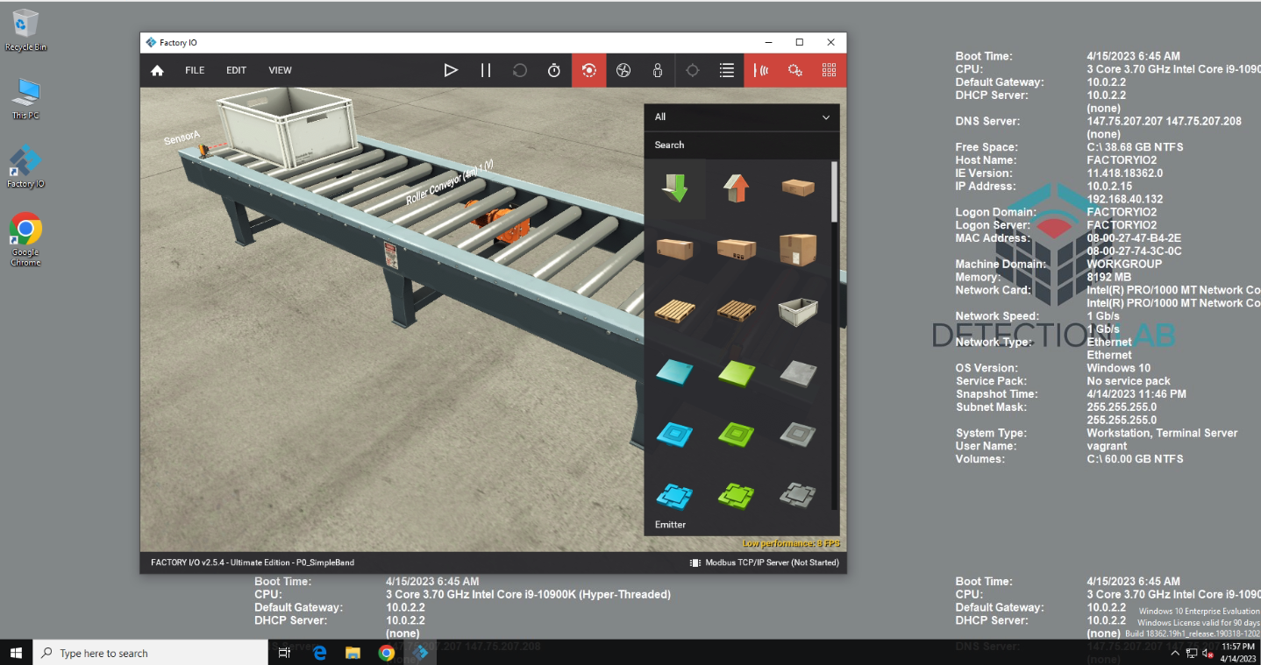

1. Go to File>Drivers   
   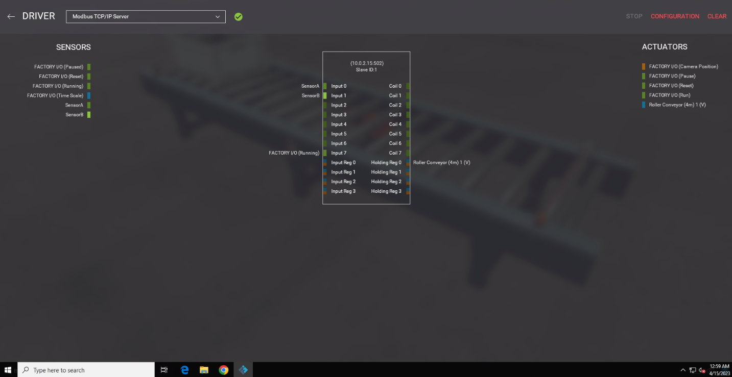
2. Click on Configuration on top right side then select 2nd option from drop-down  
   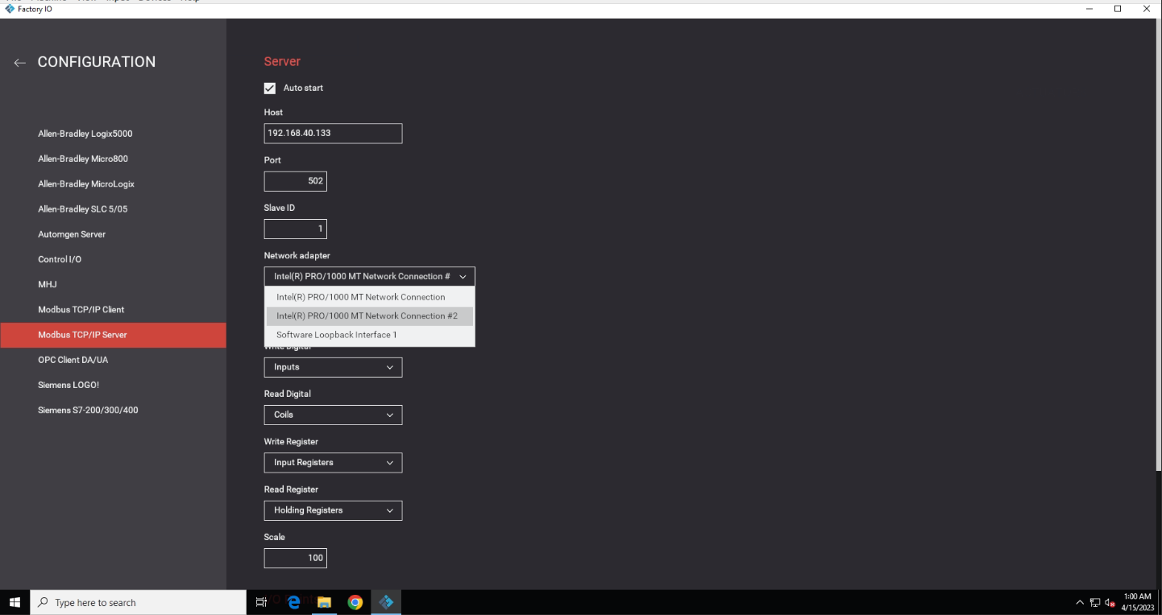
3. Make sure to remember the IP, port number and slaveID  
   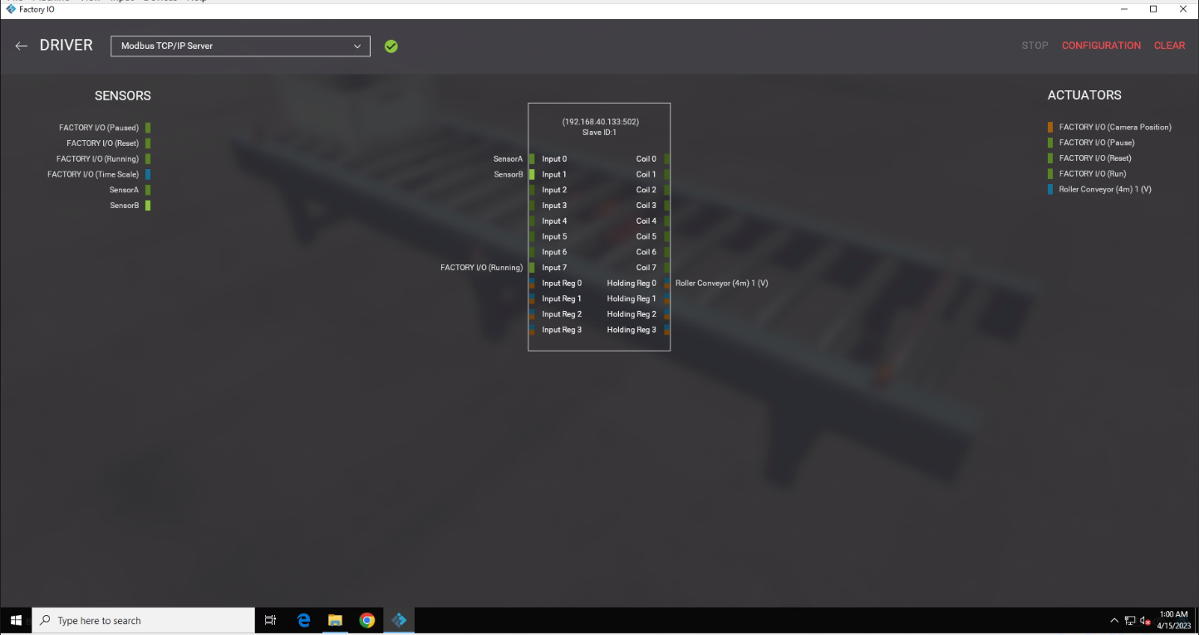
4. Go Back to main screen

Inside OpenPLC

1. Login to openPLC. Username: openplc password: openplc
2. Click on slave device then add new device(if you haven’t added earlier)  
   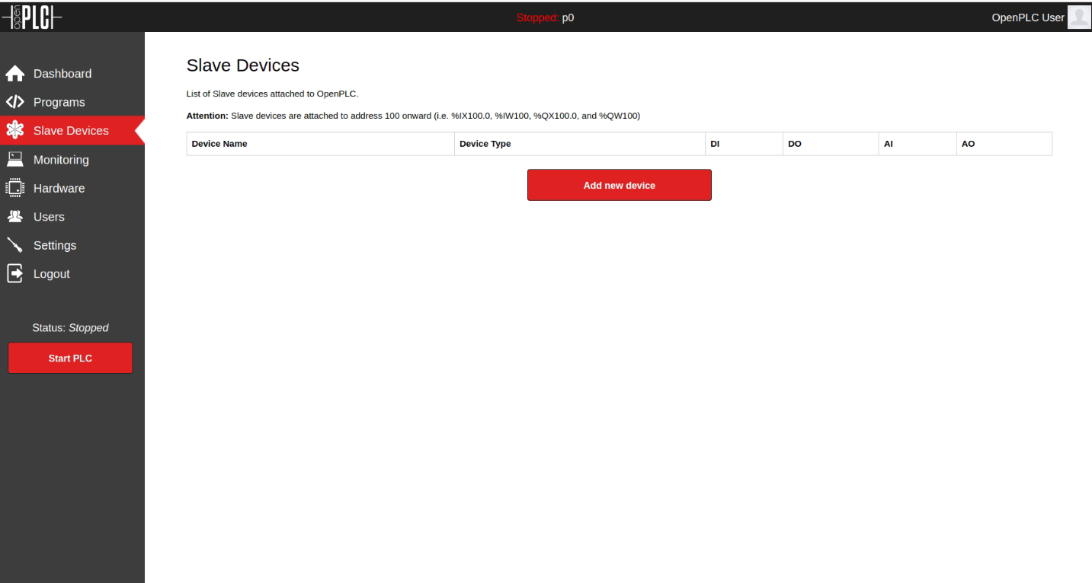
3. Fill all forms as below. Make sure you use the correct SlaveID, IP Address and IP port. You will get these info in FactoryIO machine discussed earlier.  
   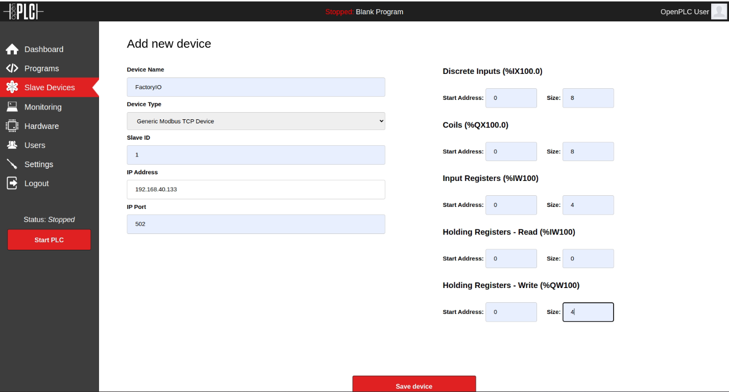
4. Save the device. Then go to Program section. You will see empty programs list if you haven’t added earlier.  
   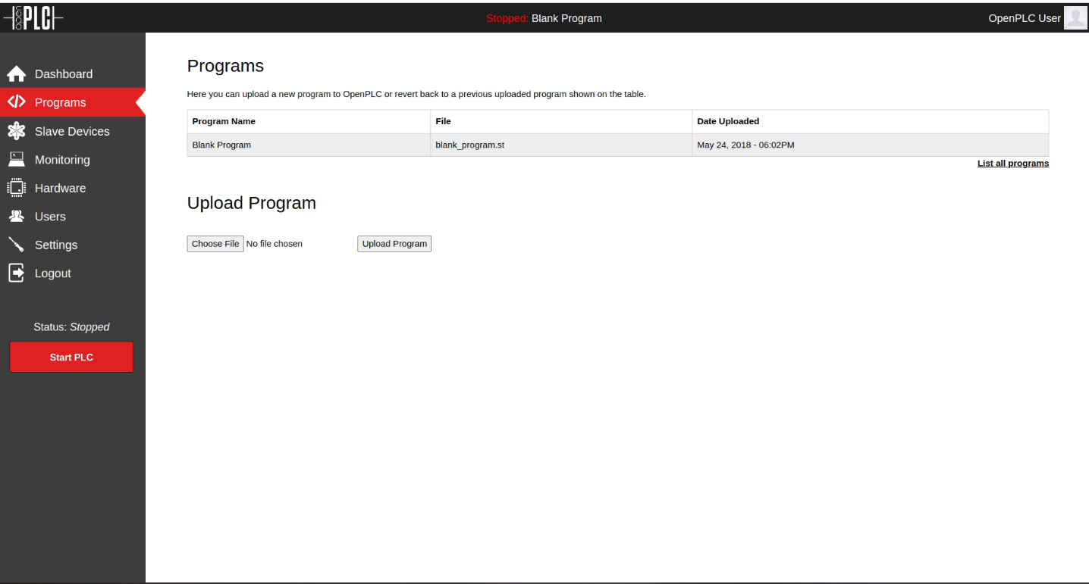
5. Click on choose file and navigate to scenes and programs then select appropriate .st file. If you have selected P0 in FactoryIO, You need to select corresponding .st file  
   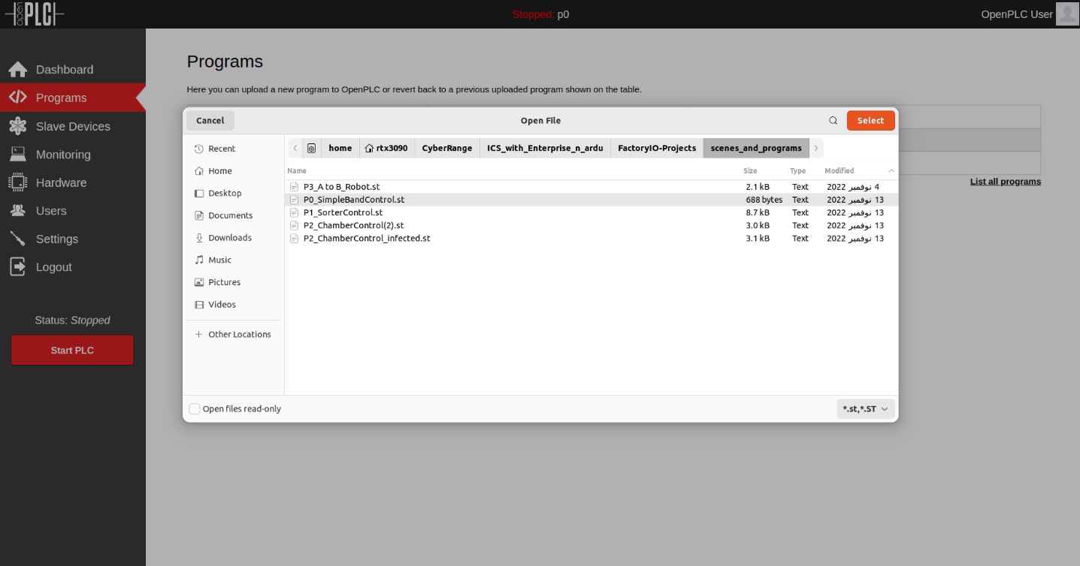
6. After selecting file, Give a name and click on upload program. Click on Go to DashBoard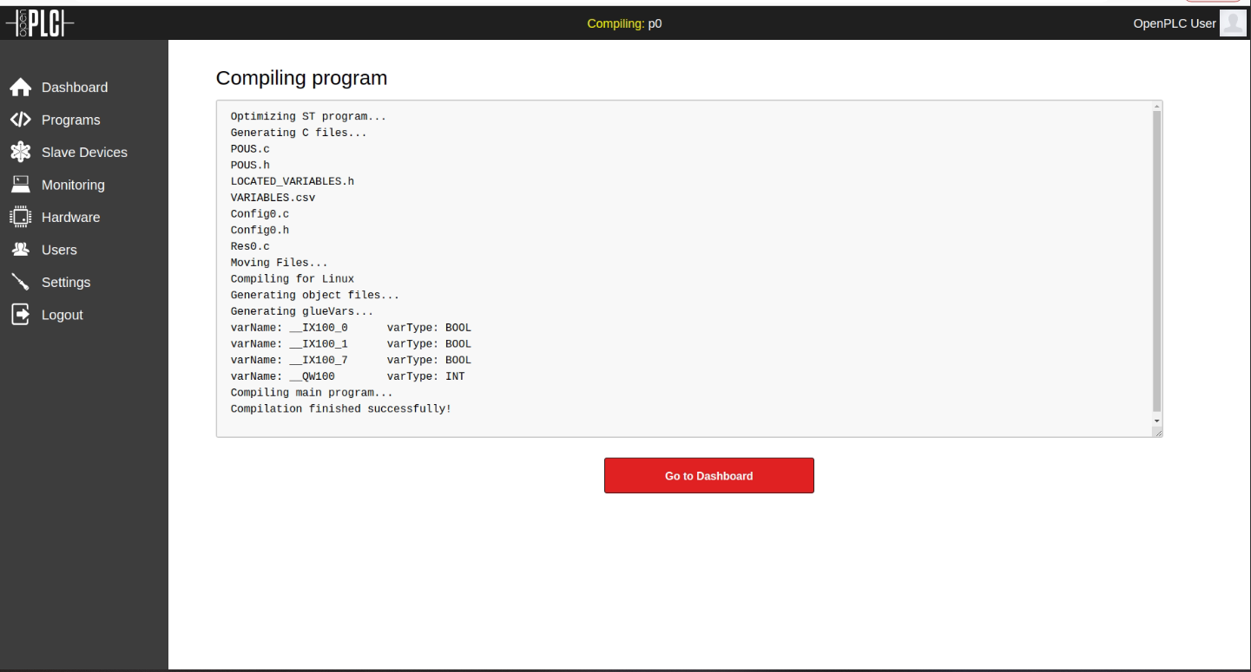
7. You will see like this  
   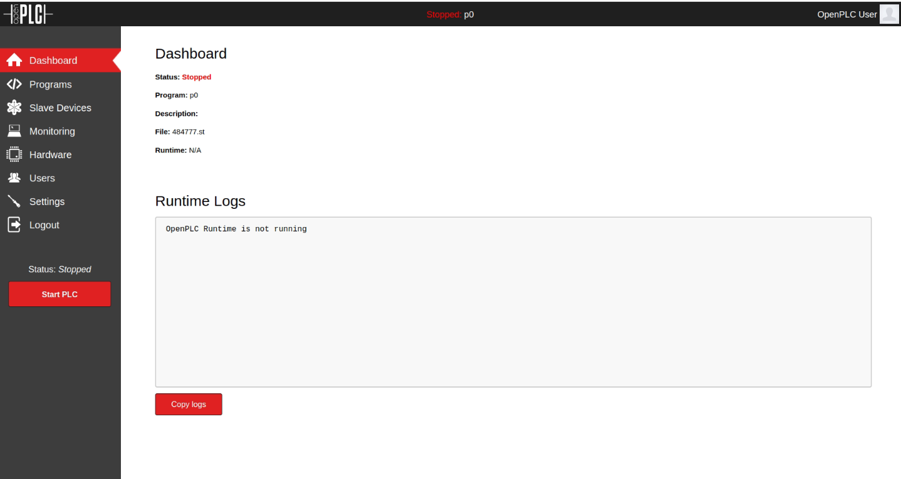
8. Go to FactoryIO and click on run. Object won’t move now  
   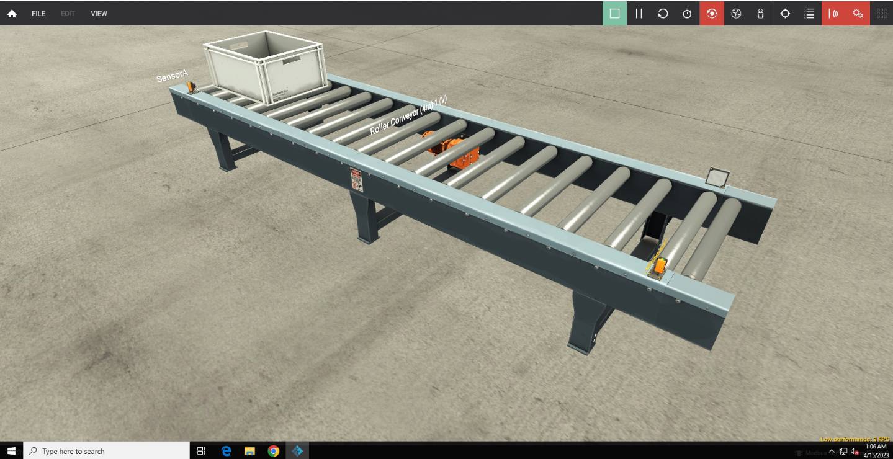
9. Go to openPLC tab and click on start plc. You will see like this  
   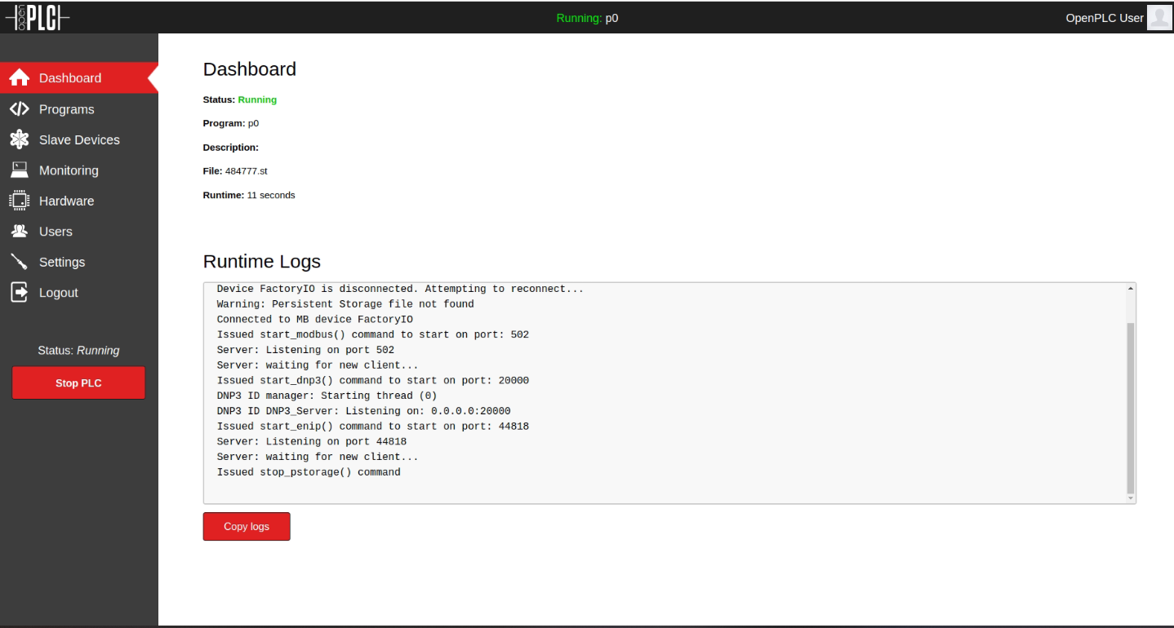
10. Go to FactoryIO. Object should start moving or simulation should start.  
    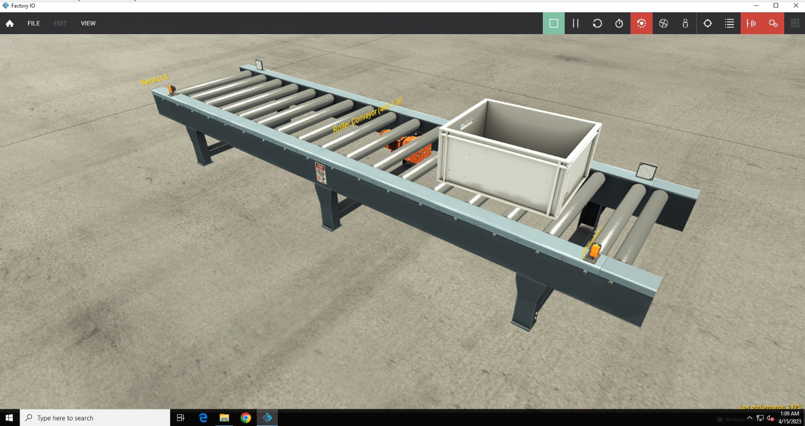

Scene is ready. For attacking,

Inside KALI

1. Navigate to this folder and open attack.py in a editor  
   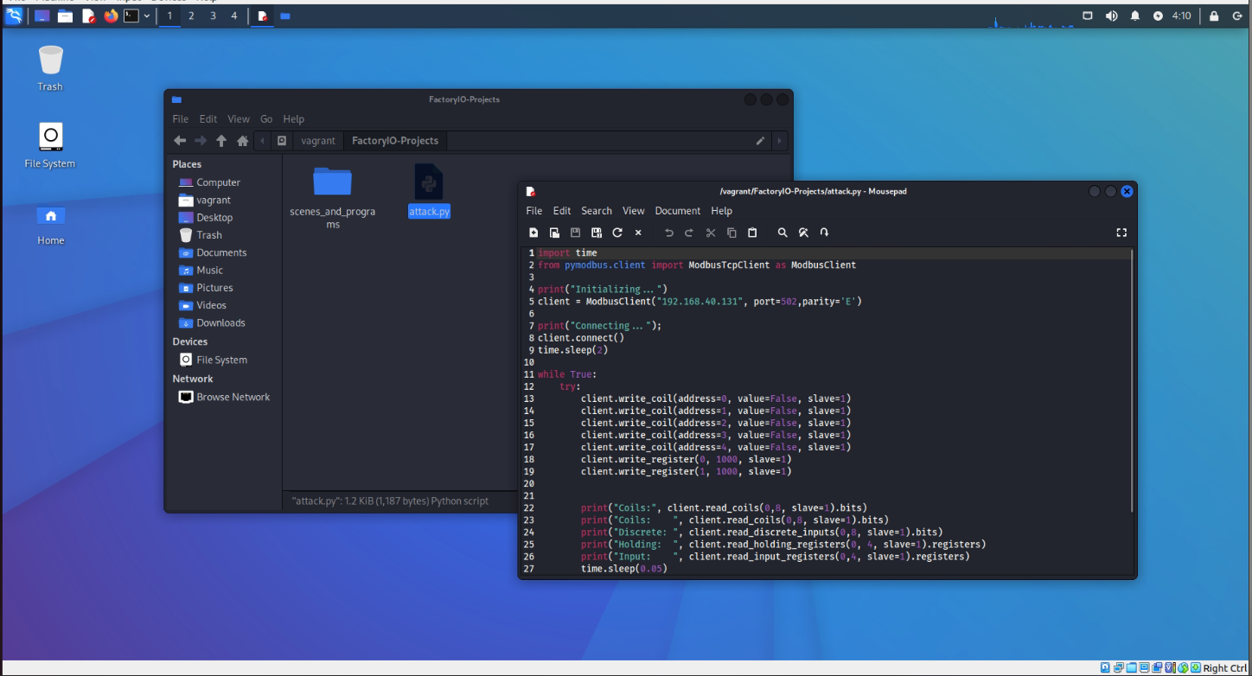
2. Make sure to change IP and port to your IP and port  
   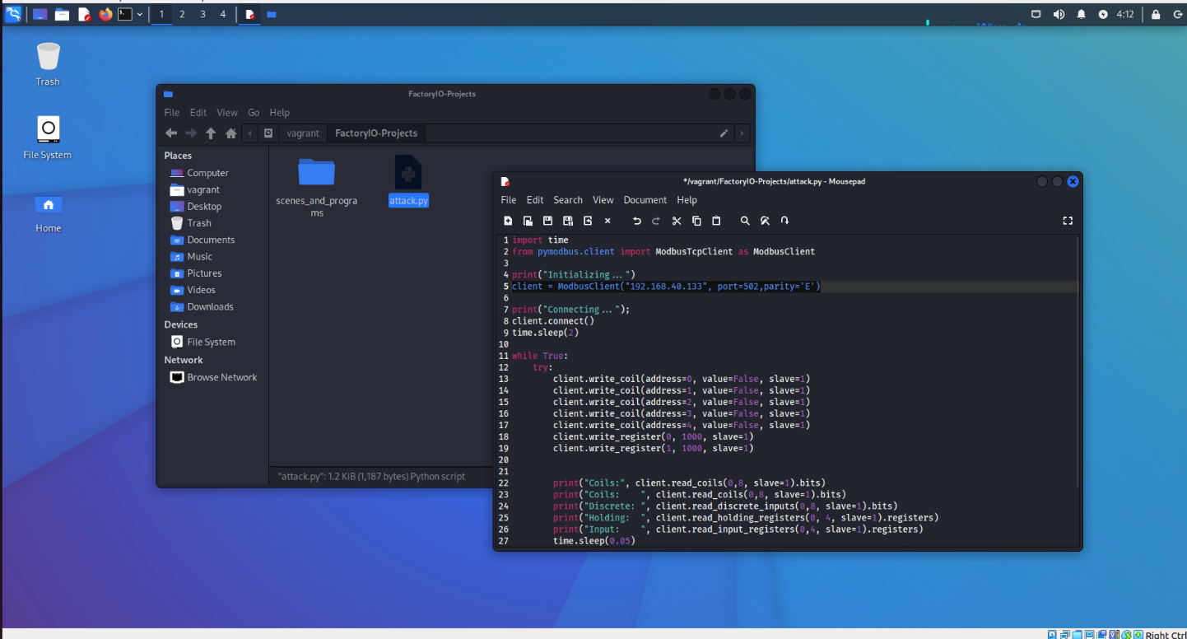
3. Save the file and open terminal there.  
   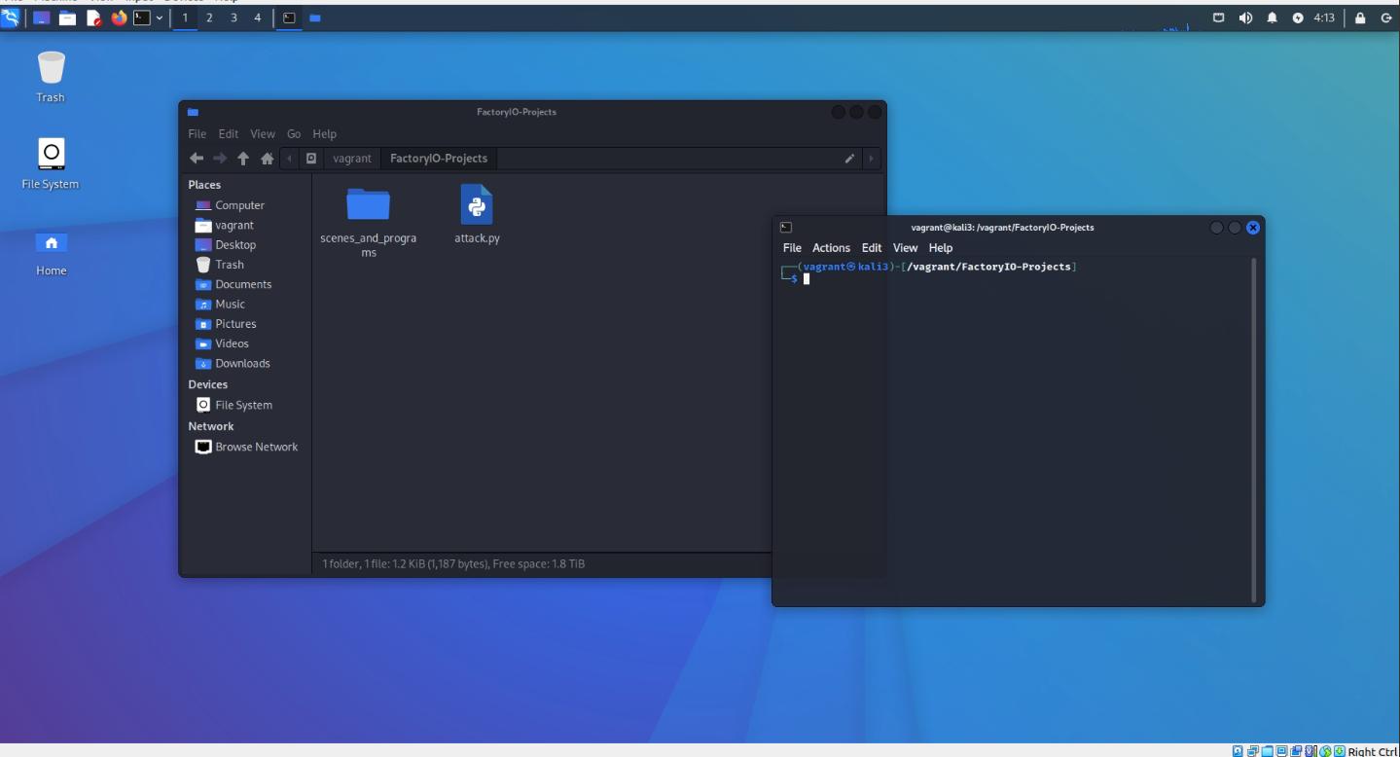
4. Execute the attack.py by running python attack.py. If you get error saying ‘No module named pymodbus’. Then install it by running pip install pymodbus  
   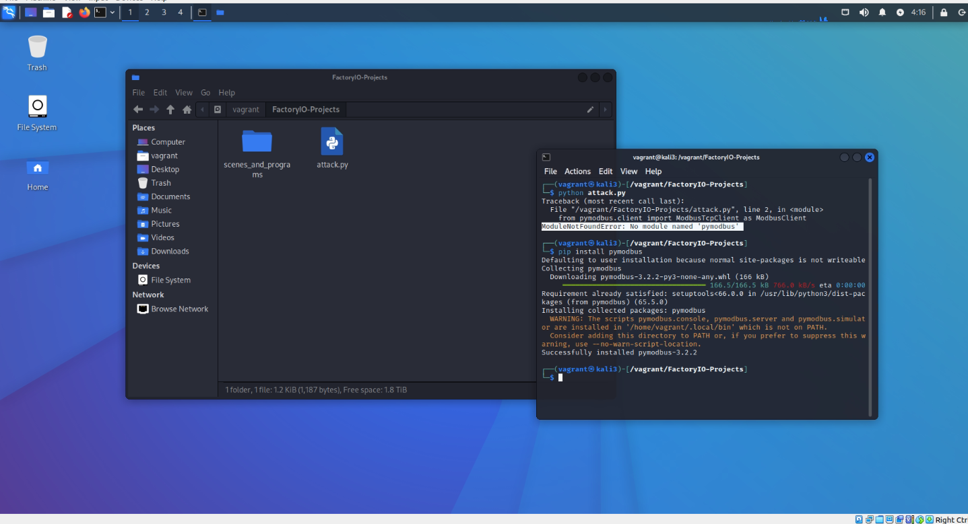
5. Execute attack.py and you should see program is executing  
   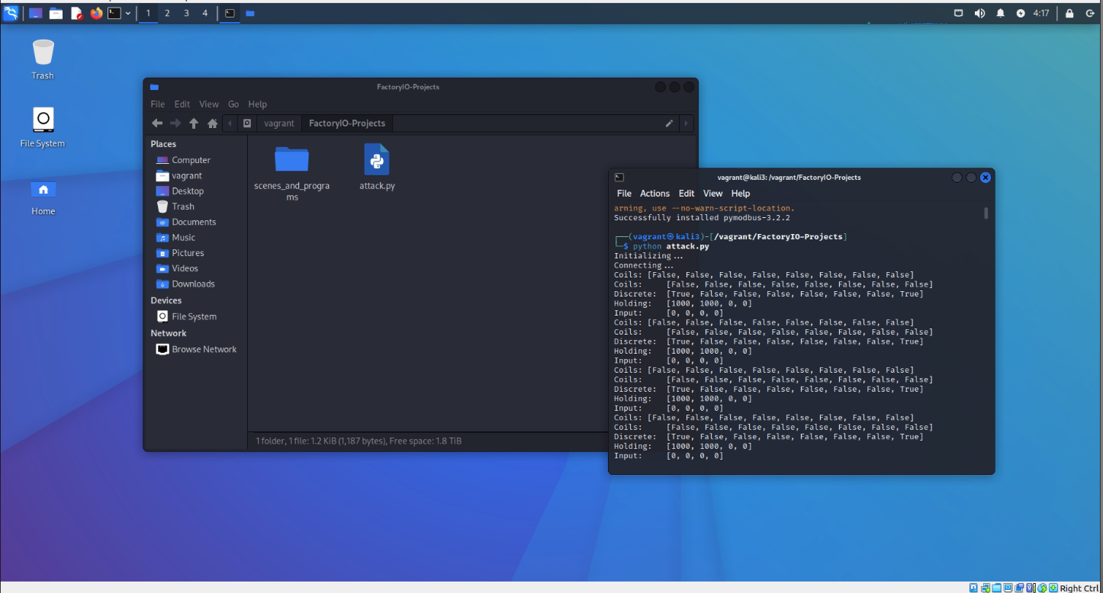

Attack is successfully completed. You can now check FactoryIO and should see scene is not working

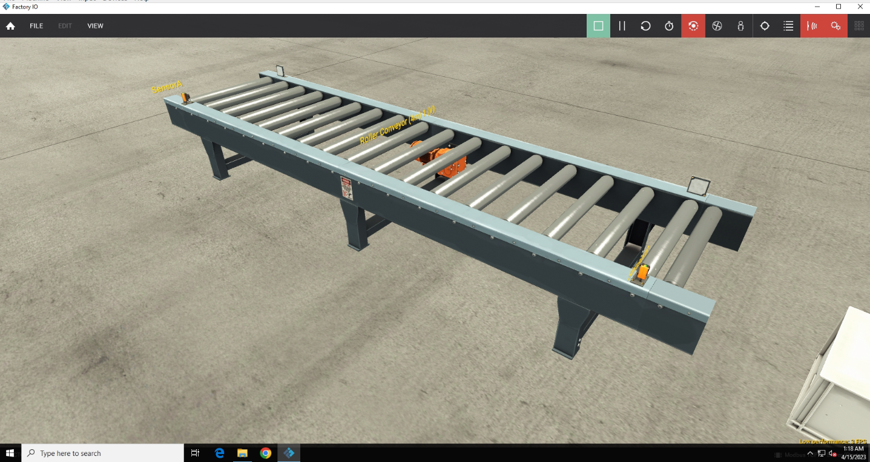

Type Ctrl+C to stop executing attack.py in kali terminal also stop the PLC